The eighth sister
Laura Girolami 2BL

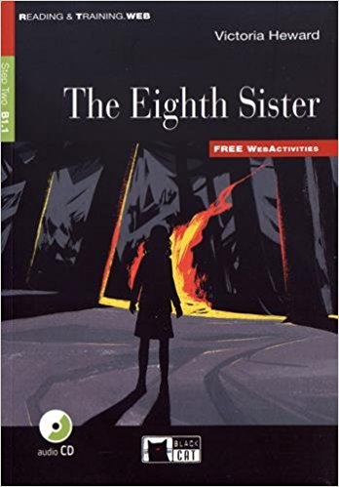
- “ The Eight Sister “ was written by Victoria Hewars in 2015, she is an English teacher for private schools and writer of short novels. This book is a mistery story set in 21st century in England. The story is located in a small village called “ Hollybrook “ that was invented by the author; some scenes are located in a small old book shop called “ Oak Tree Anthiques “ and in the house of the main character.

- The story is about the adventure of Helen, a young witch, and her cousin Will. For her birthday Helen gets a strange gift from her aunt, who everyone thought that she was dead. The gift is a necklace which belonged to her aunt. During the story Helen and Will, while reading an old book about the history of their village, find out that every girl who was born at Christmas was a witch, and Helen was one of them. She is the only one who can stop this tradition and she is the only one who can interrupt it. She will use that necklace, but something will go wrong.

- The main characters are Helen, her mother Julia, her cousin Will, aunt Susan who is Will’s mother and uncle Jo who is Will’s father. My favourite character is Helen because she is courageous, intelligent and smart. The main characters are very interesting and clever. Helen and Will are excited, but at the same time they are nervous about the events that are happening. The plot is interesting and amazing and is full of mystery scenes. The part I liked the most was the final part because it had an unexpected ending.

- To sum up the book is a mystery story. I can say that I liked this book because when I was reading it I felt really involve in the story. I cal also say that this book is situable for all ages. So if you enjoy mystery stories or mystery romance, I would recommend it.

