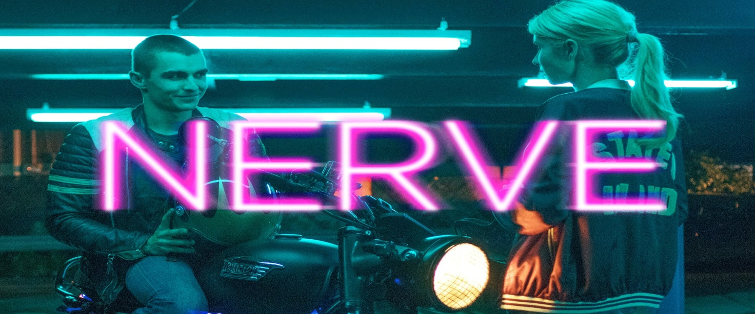
“NERVE” reviewed by Leonardo Rosatelli
The movie I want to review is “Nerve”, an amazing techno-thriller adventure.It was directed by Henry Joost and Ariel Schulman, then released by Lionsgate in 2016.The starring actors are Emma Roberts(as Vee Delmonico), Dave Franco(as Ian/Sam) and Emily Meade(as Sydney).

Vee is a regular high-school student; she is quiet, geeky, introverted and shy. She has a tense relationship with her mother, and both of them are dealing with the recent death of her brother. Sydney, Vee’s friend, becomes popular in an online game called Nerve, where you sign up and are given tasks by viewers. Once you complete a task, you get money deposited in your bank account and two most popular players face off in the final level. Vee has her reservations about the game to begin with.
But a humiliating incident, where she gets shot down by the popular boy in school, forces her to break out of her shell and sign up for the game too.
As her first task, she kisses a total stranger - Ian - who is reading her favourite book in a diner. The two share great chemistry and the viewers of the game keep giving them dares together. With each dare, the stakes rise and Vee loses herself to the thrill, like stealing dresses from an expensive shop, like walking on ladders placed between two buildings and even participating in a high-speed blind-folded motorcycle race.
She eventually realizes how dangerous the game is, and alerts the authorities…
But she doesn’t know that this hasty action is gonna get her in trouble!
How will it end?

Let’s start by saying that the movie is mostly shot at night, in NYC.In my opinion the actors are awesome and uninhibited.The central theme is the game “NERVE”, but, actually it’s just a sample to express the actual discomfort of cyber-bullying inasmuch the watchers all pay to let the players do whatever they want and the players are bound by the strict rules of the game.If I would have to describe this movie in 3 words I would say:engaging, contemporary and thought-provoking.The special effects in the film consist of neon lights and computerized images.The background music is generally techno and pop, so it perfectly fits with the scenes.The film alternates scenes made by the camera and others from smartphones.The only criticism that I can make is that the final is too obvious.

To sum up I loved it so much because it talks about a serious problem revisited in an interesting way.I would recommend it to my peers not just because is a good movie but also because you can learn something from it.Finally I must admit that this film has been the best of the whole past year.

