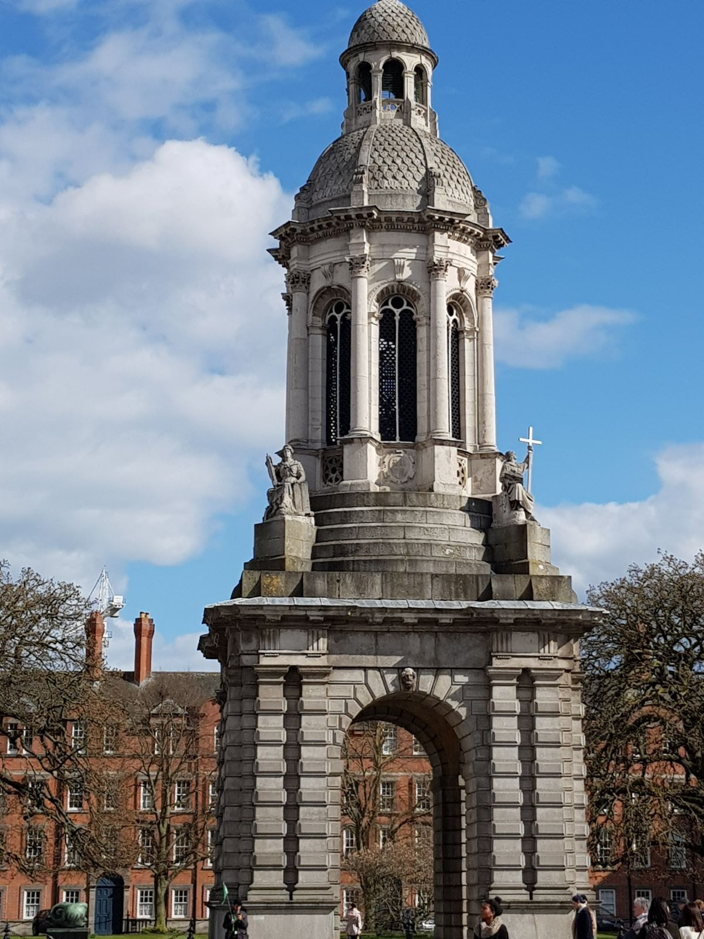

D U B L I N S T A G E 2018

6-12 March
21-27 March

The high school ''Jacopone da Todi'' allows students to participate in stages abroad.
A linguistic stage is a very important and
educational experience. Besides improving the knowledge of the language, it offers the opportunity to know new cultures and ways of living.

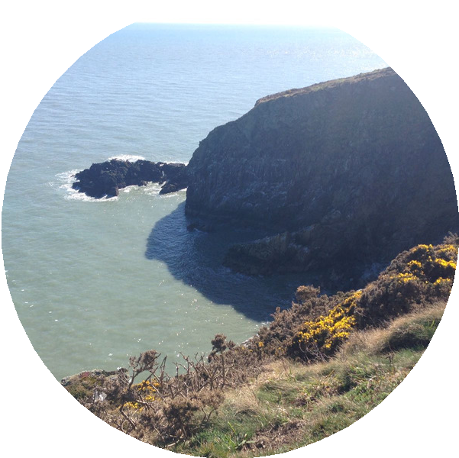I The students, accompanied by five teachers and the Headmaster, spent a week in March in the fascinating Irish capital. It was also an experience for the project of School-Job Alternation.

T h is e x p e r ie n c e is h ig h ly f o r m a t iv e
b e c a u s e it is an o pportunity t o d e e p e n,
im p r o v e and practice t he English
la n g u a g e studied at school. The stage is organized every year.

The v is it of t h e m o s t im p o r t a n t p la c e s o f D u b lin a n d t h e w o n d e r f u l c lif f s will be remembered for ever.
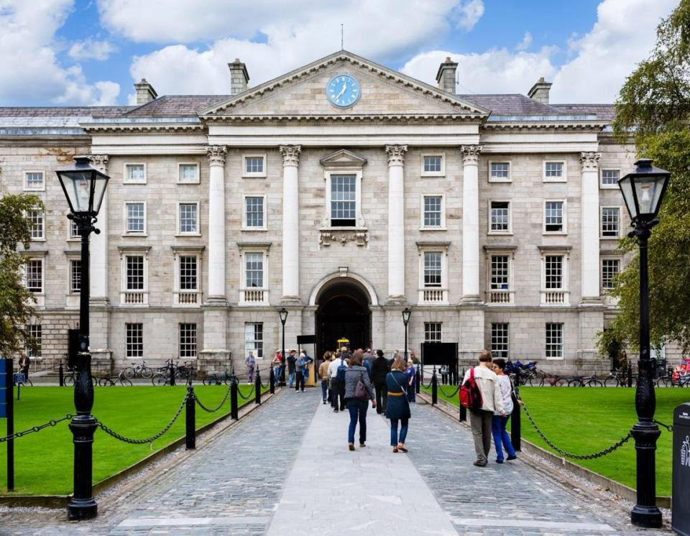Trinity College

T H E U N I V E R S I T Y O F D U B L I N ,
T R I N I T Y C O L L E G E , F O U N D E D I N 1 5 9 2 , I S T H E O L D E S T
U N I V E R S I T Y I N I R E L A N D .
T R I N I T Y C O L L E G E I S T H E S O L E C O N S T I T U E N T C O L L E G E O F T H E
U N I V E R S I T Y . A T P R E S E N T T H E R E A R E O V E R 1 2 , 0 0 0 S T U D E N T S
A N D 1 , 2 0 0 S T A F F M E M B E R S W O R K I N G O N T H E C O L L E G E C A M P U S .
T R I N I T Y C O L L E G E I S O N E O F
I R E L A N D L E A D I N G H I S T O R I C A L S I T E S , A T T R A C T I N G H A L F A M I L L I O N V I S I T O R S E V E R Y Y E A R . H E R I T A G E
A T T R A C T I O N S A V A I L A B L E T O
V I S I T O R S I N C L U D E T H E B O O K O F K E L L S A N D W A L K I N G T O U R S O F
T H E C A M P U S .

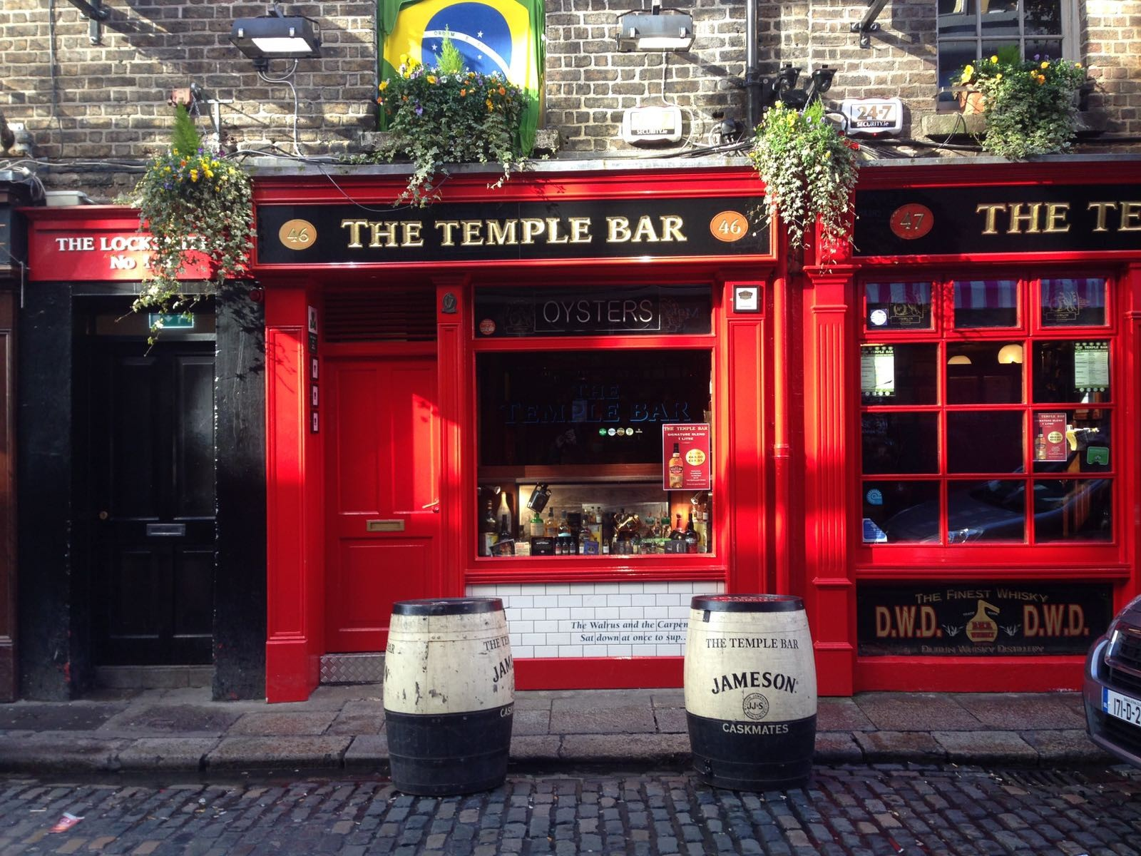 Temple Bar

T E M P L E B A R I S T H E
C E N T R E O F D U B L I N ’ S C U L T U R A L U N I V E R S E . B U S K E R S , S T R E E T
A R T I S T S , O P E N A I R M A R K E T S A N D
E X H I B I T I O N S C R E A T E A SPECIAL A T M O S P H E R E . Y O U C A N WA T C H A
S H O W , STROLL T H R O U G H A G A L L E R Y , E X P L O R E A M A R K E T , G O T O A G I G
O R J U S T P L O N K
Y O U R S E L F I N A C A F É F O R D U B L I N ’ S B E S T P E O P L E - W A T C H I N G
S P O T .

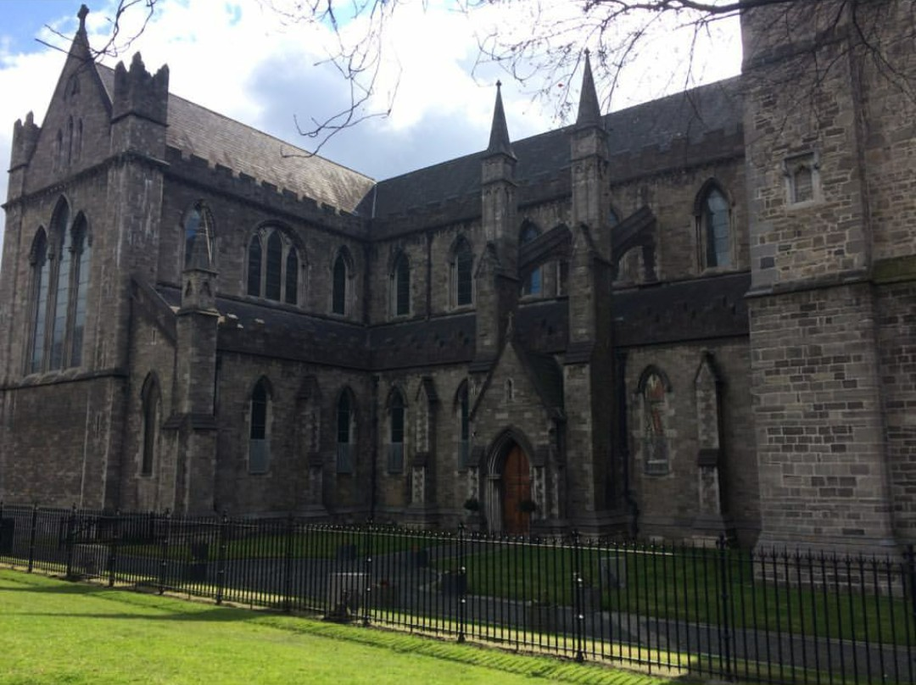St. Patrick's Cathedral

S A I N T P A T R I C K ’ S C A T H E D R A L H A S B E E N P A R T O F I R E L A N D ’ S H I S T O R Y F O R O V E R 8 0 0 Y E A R S A N D T O D A Y I S O N E O F T H E
M O S T P O P U L A R V I S I T O R A T T R A C T I O N S I N D U B L I N . B U I L T I N H O N O U R O F
I R E L A N D ’ S P A T R O N S A I N T B E T W E E N 1 2 2 0 A N D 1 2 6 0 S A I N T P A T R I C K ’ S
C A T H E D R A L O F F E R S V I S I T O R S A R I C H A N D C O M P E L L I N G C U L T U R A L
E X P E R I E N C E A N D I S O N E O F T H E F E W B U I L D I N G S L E F T F R O M M E D I E V A L
D U B L I N . I T I S T H E N A T I O N A L
C A T H E D R A L O F T H E C H U R C H O F I R E L A N D A N D I S T H E L A R G E S T
C A T H E D R A L I N T H E C O U N T R Y . T H E
C A T H E D R A L I S W O R L D F A M O U S F O R I T S C H O I R W H I C H S T I L L P E R F O R M S D A I L Y
D U R I N G S C H O O L T E R M A N D I N R E C E N T Y E A R S T H E L A D Y C H A P E L , D A T I N G F R O M 1 2 7 0 , H A S B E E N R E S T O R E D T O I T S
O R I G I N A L G L O R Y A N D A N E W E X H I B I T I O N C A L L E D L I V E S
R E M E M B E R E D H A S O P E N E D W H I C H
I N C L U D E S A S P E C I A L L Y C O M M I S S I O N E D T R E E S C U L P T U R E A N D M A R K S T H E
C E N T E N A R Y O F W O R L D W A R 1 .

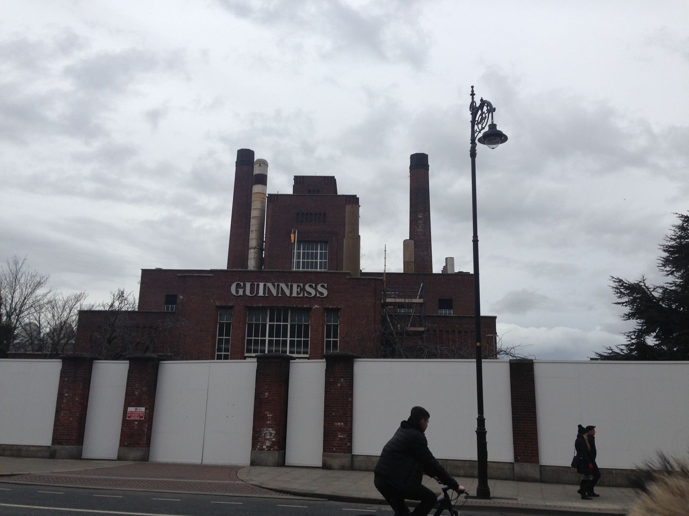Guinness Storehouse
L O C A T E D I N T H E H E A R T O F T H E S T . J A M E S ' S G A T E B R E W E R Y , T H E
G U I N N E S S S T O R E H O U S E I S
I R E L A N D ' S M O S T P O P U L A R T O U R I S T A T T R A C T I O N . I T ' S T H E H O M E O F T H E B L A C K S T U F F , T H E H E A R T O F
D U B L I N A N D A N U N F O R G E T T A B L E
S T A R T T O Y O U R I R I S H A D V E N T U R E . T H E J O U R N E Y B E G I N S A T T H E
B O T T O M O F T H E W O R L D ' S L A R G E S T P I N T G L A S S A N D C O N T I N U E S U P
T H R O U G H S E V E N F L O O R S F I L L E D W I T H I N T E R A C T I V E E X P E R I E N C E S T H A T F U S E O U R L O N G B R E W I N G
H E R I T A G E W I T H I R E L A N D ' S R I C H H I S T O R Y . A T T H E T O P , Y O U ' L L B E R E W A R D E D W I T H A P I N T O F
P E R F E C T I O N I N O U R W O R L D -
F A M O U S R O O F T O P G R A V I T Y B A R .
N O W T H A T ' S O U R K I N D O F H I G H E R E D U C A T I O N .

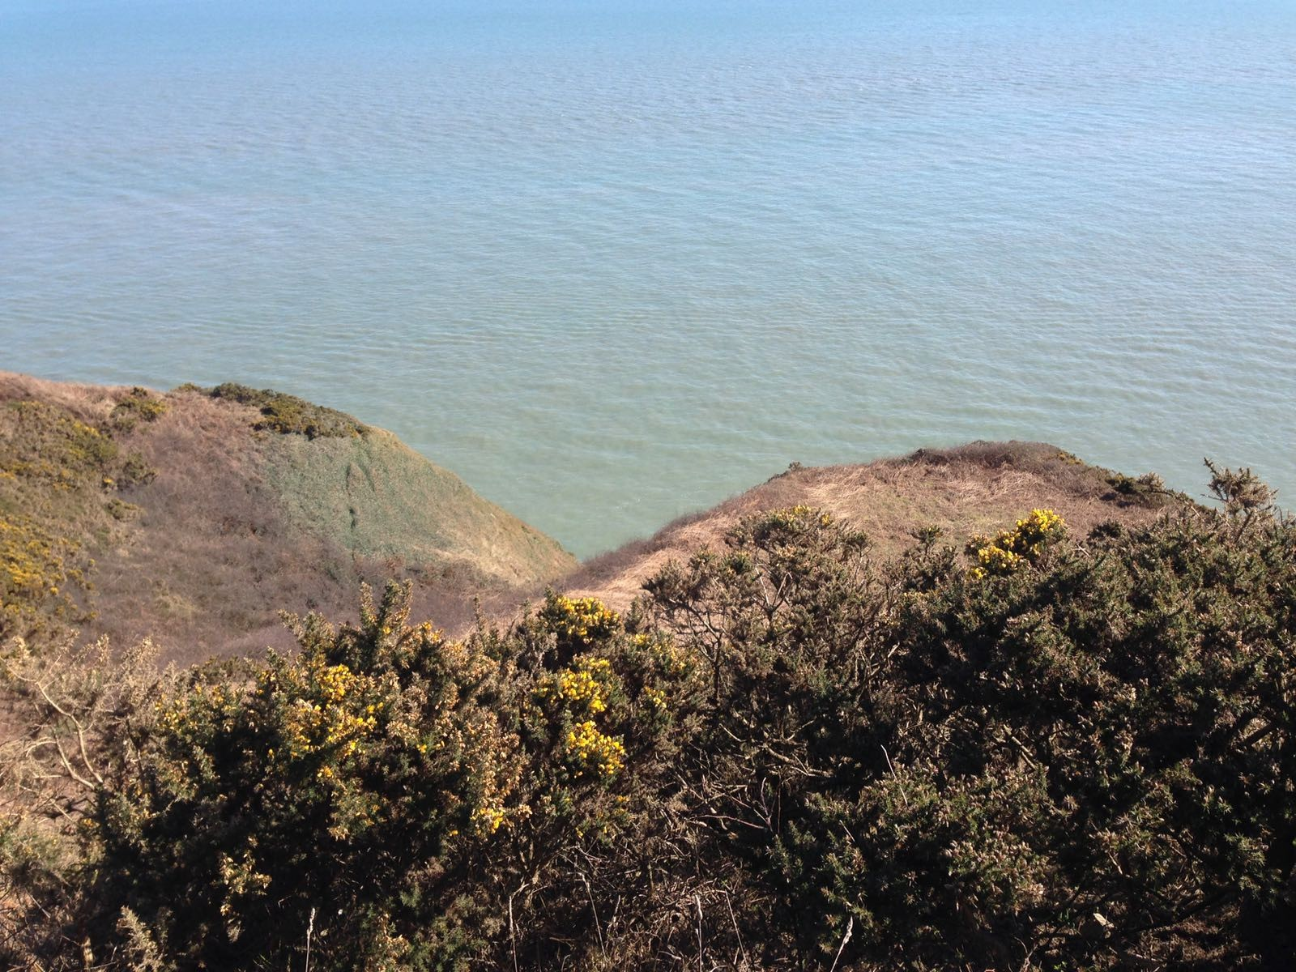Howth

I M M E D I A T E L Y N O R T H - E A S T O F
T H E I R I S H C A P I T A L , H O W T H I S A S M A L L S U B U R B O C C U P Y I N G T H E P E N I N S U L A T H A T C L O S E S O F F
D U B L I N B A Y . I T M A K E S F O R A N I D E A L E S C A P E F R O M T H E C I T Y , E S P E C I A L L Y F O R T H O S E W I T H A H I R ED C A R A T T H E I R D I S P O S A L W I T H E N O U G H A C T I V I T I E S O N
H A N D T O O C C U P Y A N E N T I R E D A Y . H O W T H I S A R R A N G E D O N A
H I L L T O P S U R R O U N D E D B Y C L I F F S . I T W A S O R I G I N A L L Y A S M A L L
F I S H I N G T O W N B U T H A S G R O W N
I N T O A T H R I V I N G Y A C H T H A R B O U R A N D U P - M A R K E T R E S I D E N T I A L
D I S T R I C T .
V I S I T O R S C A N C L I M B T O H O W T H S U M M I T F O R A V I E W O V E R T H E S U R R O U N D I N G A R E A .

