N0TTING HILL
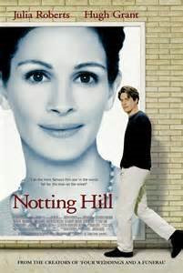
“Notting Hill” is a 1999 British romantic comedy film set in Notting Hill, London, released on 21 May 1999. The screenplay was written by Richard Curtis and the film was produced by Duncan Kenworthy and directed by Roger Mitchell. “Notting Hill” was well received by critics and became the highest grossing British film released that year.

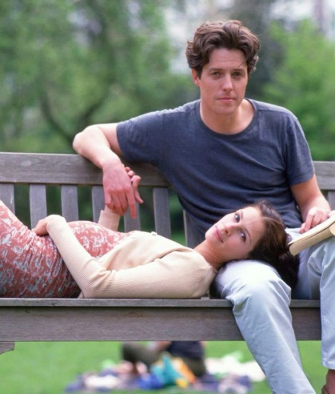
Well, of course, the moment we see Julia Roberts and Hugh Grant on the screen, we want to see them snogging, but a romantic comedy like “Notting Hill” is about delaying the inevitable. After all, they live in two different worlds. Her character, Anna, is one of the most famous movie stars in the world. His character, William, runs a modest little travel book shop in London. He is divorced and shares is house with an eccentric, care-free Welshman named Spike. We know they are destined for each other, but we are always quicker to see these things than the characters are. The film begins with a Meet Cute; she wanders into his bookstore, and their eyes, as they say, meet. They will have to meet again. If there is a thing this movie has, luckily, it is an endless supply of Meet Cutes. The next time they meet, it is by accident and he spills orange juice all over her. That leads to an invitation to clean up at his nearby flat, which leads to a kiss, but then they separate again. Will Anna and William never find the happiness they deserve? They will surely fall in love.

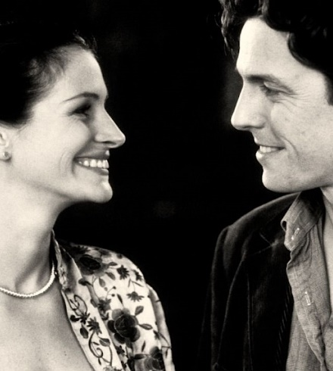
The plot is full of romantic and funny scenes and the main characters are generally really interesting, funny and most of all really strange. William Thacker is a man like the others but he is fed-up of his usual life. Anna is a very beautiful woman but now she does not want to be a star but lives her life like a normal person. Another criticism that can be made about this movie is that the love between Anna and William is a bit too obvious.

To sum up, the movie is an exciting story of love. If you enjoy romance and comedy, I would definitely recommend seeing this incredible film.

