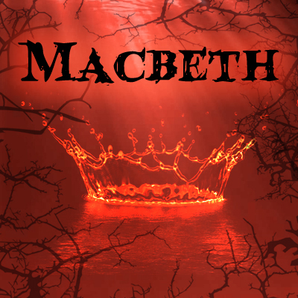
REVIEW MACBETH.

Macbeth is part of a collection of books for readers of all ages, who want to read timeless classics. The book is edited by ELI in 2011 and it is beautiful illustrated to capture the essence of this wonderful and involving tragedy.
The story is about Macbeth, a Scottish general. One day he and Banquo come back from a battle and suddenly three witches appear and Banquo and Macbeth receive some prophecies from them. The witches say to Macbeth that he will become King of Cawdor and of Scotland. Macbeth does not believe in it but after that a man says to him that King of Scotland decided that the Scottish general now is the new King of Cawdor. He is very excited and now he thinks that the witches are right so he and his wife start to think about murder Duncan, the thane of Scotland to become the new Scottish king.
He is not very brave and confident but at the end kills Duncan. Everyone thinks that the servants have killed the king because there is a lot of blood on their bodies, but Macbeth knows that he is Duncan’s murderer.
Malcom, a Duncan’s son, escapes to England and people start to think that he is the murderer of his father, so they decide that Macbeth must be the new king of Scotland and his wife the queen.
Then Macbeth plans to kill Banquo and his son, but his plane goes wrong. Banquo is killed but Fleance, his son, escapes. After that Macbeth becomes insane. At a royal banquet he sees the ghost of Banquo sitting on his chair and Lady Macbeth tries in vain to calm him. After that Macbeth kills the innocent Lady Macduff and her children, so Malcom and Macduff decide to murder Macbeth.
At the end Lady Macbeth becomes insane and commits suicide. Macduff kills Macbeth and become the new king of Scotland.
The character are very interesting. Macbeth is a brave man but he is not very confident. Lad Macbeth is a very brave woman but at the end we can see that she is as strong as we thought. Duncan was a good King and was loved by people, his sons love their father. Macduff loves his family and he is a revengeful man in fact he kills Macbeth for revenge.
This book is very exciting. It has a lot of action scenes. In this book there is a mix of emotions like love, anger, courage, loyalty and often betrayal.
If you enjoy action, I would recommend reading this book.

